Course Name: | Artificial Intelligence Laboratory | Semester: | VI
Date of Performance: | 12 / 02 / 26 | DIV/ Batch No: | A1
Student Name: | Aaryan Sharma | Roll No: | 16010123012

Experiment No:3
Title: Implementation of uninformed search algorithms

Aim: Implementation of uninformed search algorithms – BFS,DFS, DLS for the given problem

Objectives of the Experiment:
- Examine the efficiency and performance of uninformed search algorithms in solving various problems.

COs to be achieved:
CO2: Analyse and solve problems for goal based agent architecture (searching and planning algorithms)

Books/ Journals/ Websites referred:
https://www.geeksforgeeks.org/

Theory:

Problem-Solving Agent
A problem-solving agent is designed to find solutions to well-defined problems. This agent typically follows these steps:
- Formulate the Problem: Define the initial state, goal state, and possible actions.
- Search for a Solution: Use an appropriate search strategy to explore the problem space.
- Execute the Solution: Apply the sequence of actions derived from the search.

Uninformed Search Algorithms
Uninformed search algorithms, also known as blind search algorithms, are basic search strategies that explore the search space without any additional information about the goal's location beyond what is provided in the problem definition.
Uninformed Searching Technique
- Breadth-First Search (BFS): Explores all nodes at the present depth level before moving on to nodes at the next depth level. Complete and optimal if the cost is uniform.
- Depth-First Search (DFS): Explores as far as possible along each branch before backtracking. Not complete or optimal, but requires less memory.
- Depth-Limited Search (DLS): Depth-first search with a predetermined depth limit. Can overcome infinite path problems.
Activity:
Problem Formulation: Define initial state, goal state, and actions for the given problem
Construct a state-space tree for the given problem.
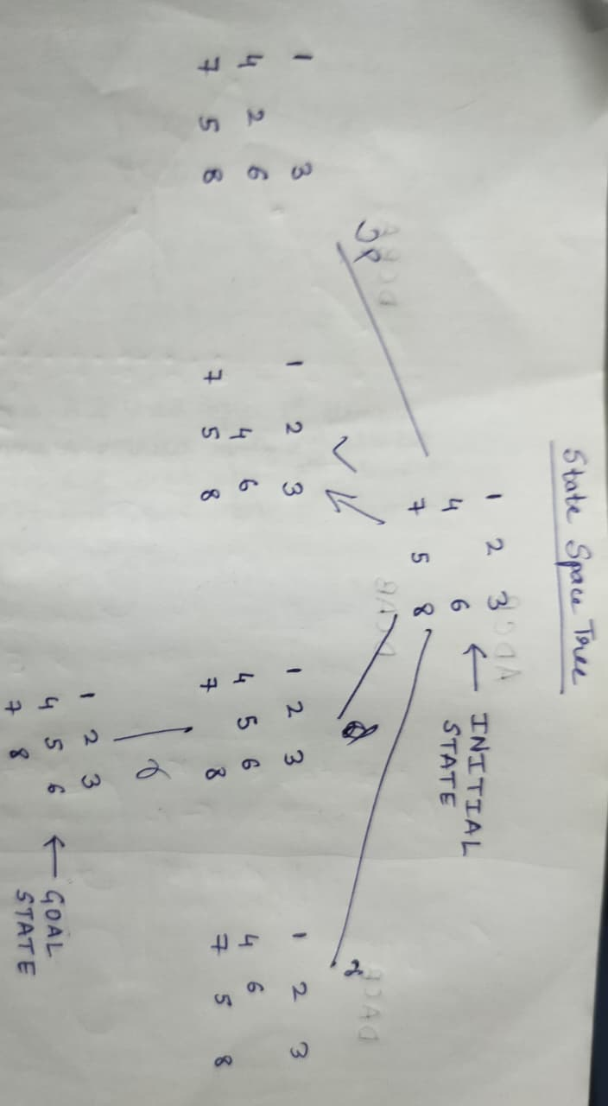
Code:
#include <bits/stdc++.h>
using namespace std;
struct Node {
vector<vector<int>> s;
int x,y;
};

vector<vector<int>> goal = {
{1,2,3},
{4,5,6},
{7,8,0}
};

set<string> visited;

string key(vector<vector<int>> a){
string r="";
for(auto &i:a)
for(int j:i) r+=to_string(j);
return r;
}

void printState(vector<vector<int>> s,int depth){
for(int i=0;i<depth;i++) cout<<" ";
cout<<"[\n";
for(auto &r:s){
for(int i=0;i<depth;i++) cout<<" ";
for(int v:r) cout<<v<<" ";
cout<<"\n";
}
for(int i=0;i<depth;i++) cout<<" ";
cout<<"]\n";
}

bool DLS(Node n,int depth,int limit){

string k=key(n.s);
if(visited.count(k)){
for(int i=0;i<depth;i++) cout<<" ";
cout<<"Cycle -> Rejected\n";
return false;
}

visited.insert(k);

printState(n.s,depth);

if(n.s==goal){
for(int i=0;i<depth;i++) cout<<" ";
cout<<"GOAL FOUND\n";
return true;
}

if(depth==limit){
for(int i=0;i<depth;i++) cout<<" ";
cout<<"Depth Cutoff -> DEAD END\n";
return false;
}

int dx[]={-1,1,0,0};
int dy[]={0,0,-1,1};

for(int i=0;i<4;i++){
int nx=n.x+dx[i];
int ny=n.y+dy[i];

if(nx>=0 && nx<3 && ny>=0 && ny<3){
Node c=n;
swap(c.s[n.x][n.y],c.s[nx][ny]);
c.x=nx; c.y=ny;

if(DLS(c,depth+1,limit))
return true;
}
}

for(int i=0;i<depth;i++) cout<<" ";
cout<<"Backtrack\n";
return false;
}

int main(){

vector<vector<int>> start={
{1,2,3},
{4,0,6},
{7,5,8}
};

Node root;
root.s=start;

for(int i=0;i<3;i++)
for(int j=0;j<3;j++)
if(start[i][j]==0){
root.x=i;
root.y=j;
}

cout<<"INITIAL STATE\n";
printState(start,0);

cout<<"\nGOAL STATE\n";
printState(goal,0);

cout<<"\nSTATE SPACE TREE (DLS, Depth Limit = 2)\n\n";

DLS(root,0,2);

return 0;
}
Output:
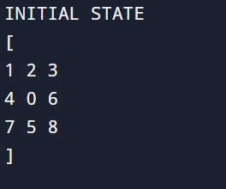

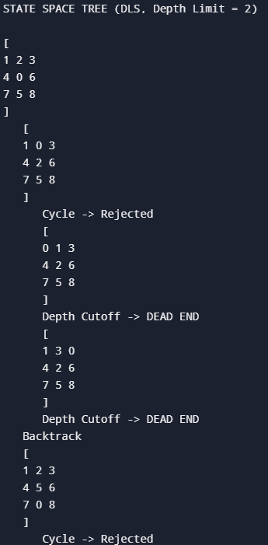
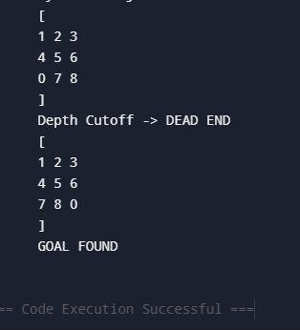

Post Lab Subjective/Objective type Questions:
Question: Answer in brief (Hand written answers)
- Differentiate between BFS, DFS, DLS and IDS.
- Which algorithm guarantees the shortest path? Why?
- What is the disadvantage of DFS?
- Why is DLS preferred over DFS in some cases?
- Construct the state space tree. Apply the given algorithm to find the path (from a → f).
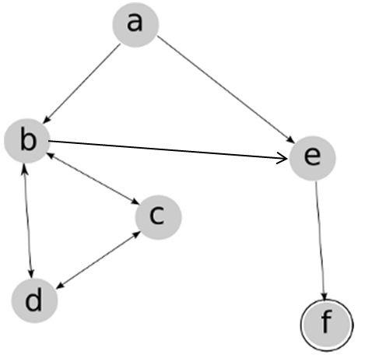
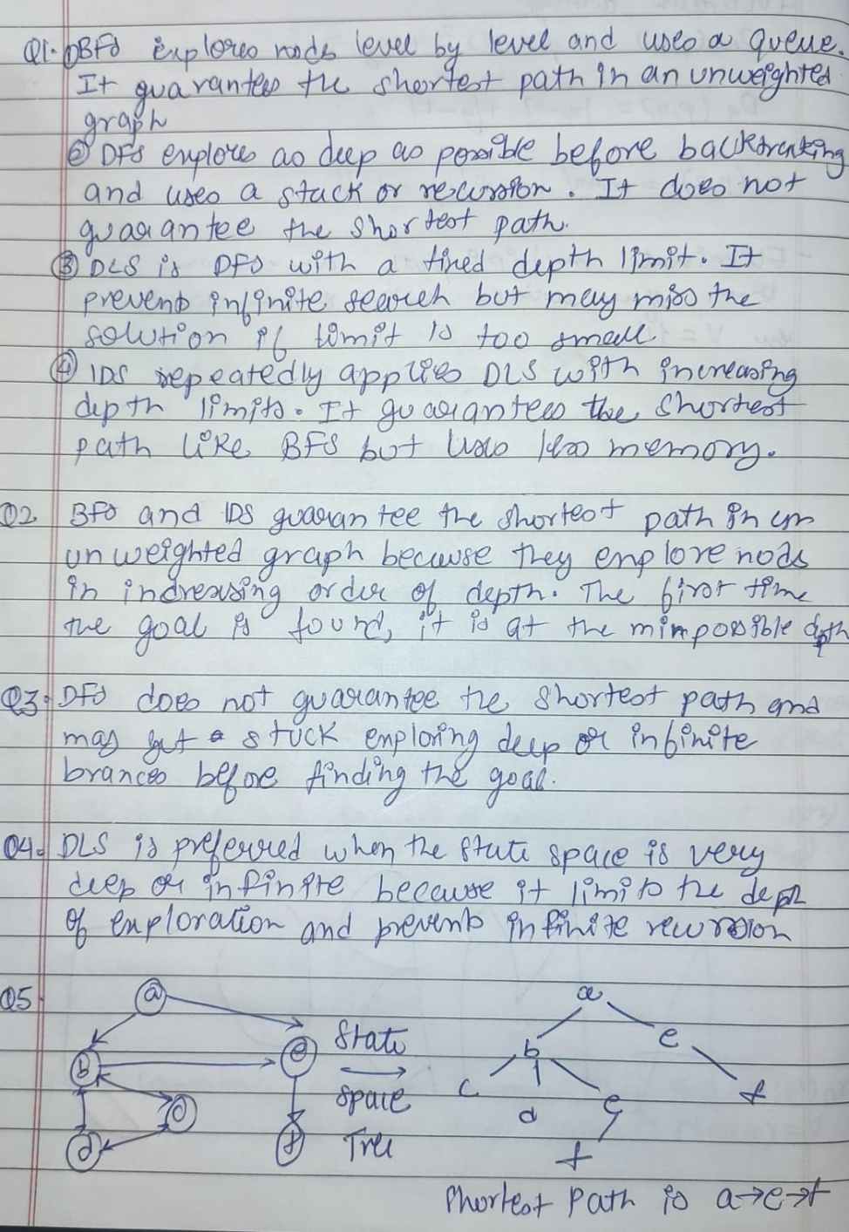

Conclusion:
In this experiment, we used Depth-Limited Search (DLS) to solve the 8-puzzle problem. By defining the initial state, goal state, and possible moves, we applied DLS to explore the state space up to a fixed depth limit. This helped prevent infinite searching and reduced unnecessary exploration. Through this activity, we understood how DLS works in practical problem-solving and how setting a depth limit makes the search process more controlled and efficient. The experiment improved our understanding of uninformed search techniques and their application in Artificial Intelligence.

